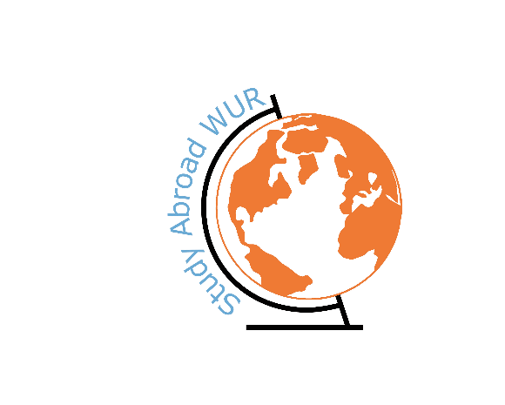

WUR Goes Abroad

1. Student Information
Study programme WUR | Internationale ontwikkelings studies
Exchange semester (dd/mm/yyyy) | 01-09-2023 until 31-01-2024
Exchange destination: University | University of Latvia
Faculty | Social sciences
Country | Latvia
City | Riga

2. Motivation for exchange

Why did you choose to go on study exchange?
Because I wanted to study abroad and experience a different culture.
What is the reason you chose for this country/university?
I Hadn’t been in the Baltics yes and this was a nice opportunity to go there and experience Latvia and the other Baltic countries

3. Accessibility to reach destination

Do you have any tips to reach your exchange destination?
Flying with Transavia is cheapest with good service. You can buy bus ticktets at the busstation on the airport to got to the city center or get a bolt. Don’t go with the regular taxi’s they are expensive.

4. University and studying

Could you provide some general information about the followed courses?
 | Course | ECTS | Short description of the contents | Appreciation of course: 1(low) – 5(high) | Remarks
1 | Foreign policy analysis | 6 | Information on foreign policy theory with practical application | 4
2 | International public law | 6 | Information on public law theory with practical application | 5
3 | Governing International economic relations | 3 | Very practical approach to international economic relations | 3
4 | Anthropology on religion and ritual | 6 | Information on anthropological theory of religion and ritual with a practical application | 4
5 | Anthropology of things | 6 | Information on anthropological theory of Things | 2
6

What is it like to study there?

For me studying in Latvia was very similar to Dutch high schools almost all my classes were with 20 to 40 students with only one lecturer who did everything from giving lectures to organizing discussion groups and grading assignments. The academic level varies enormously between courses even within the same bachelor so it’s hard to give an explanation on the academic level because it varied so widely. Examanation were mostly the same as in Wageningen. Workload also vastly differed between courses. Practice material for most courses was pretty scarce.

What is the culture of the university?

Lecturers are usually very approachable and have a good relationship with their students. Local students are nice but don’t expect to much interaction with them outside the classroom. Culture doesn’t differ to much from the WUR.

What does the university offer students additionally?

Facilities were generally very bad. Most faculties didn’t have any catering only some vending machines. They promised that there would be a wide variety of options for sports but this was very limited and hard to find.

5.Housing-travelling-living

What are the possibilities for housing?

Rooms from the university are very limited but there are more then enough private rooms to rent with more then respectable prices for a big city. You’ll easily find a room for under 500 euros.

What is the culture of the country like?

A bit boring, people are very introverted and show very little emotion. Local cuisine is pretty boring and is kind of like an old fashioned version of Dutch quisine. People in public transport especially busses can be quite rude and rushed. People generally are really nice and helpful and most people at least speak some English.

Could you give some information about public transport infrastructure?
You get a public transport card through the university. For 15 euros a month you can travel freely with bus and tram throughout the whole of Riga. Trams are generally on Time busses are sometimes late or don’t come at all. Bolt taxi’s are fairly cheap you can get to pretty much anywhere in the city from the center for less than 10 euros. The university is spread throughout the city so you most likely need to take a bus to university. Trains are cheap one way ticket are maximum 5 euros but trains are also very slow and there are very few trains in Latvia.

6. Expenses

Can you give an indication of your expenses for/during your exchange?
E.g. you can also indicate price differences (higher/lower/equal) in comparison to the Netherlands.

Ticket there: A one way ticket is around or a little cheaper than 100 euros with 25 kg of baggage. (heavily dependent on when you go)
Visa if applicable: -
Vaccinations if applicable: -
Insurances (extra, if applicable): -
Housing costs per month & type of housing/accommodation: most people paid between 300-500 euros for a room on their own in a shared apartment.
Groceries: similar or a little cheaper than the Netherlands
Public transport: 15 euros a month for within Riga
Restaurant/going out for dinner: similar or a little cheaper than the Netherlands.
Daytrips/sight-seeing: museums are usually cheaper then here most for under then euros. For other things it really depends on where you go.

Additional remarks regarding expenses?

7. Free time

What are must-sees in the area?

Jurmula, kemeri, Sigulda, Ogre(in winter), Tallinn, Vilnius, Kaunas?

What does not appear in a travel guide, but is definitely worth a visit?
Do you have general tips and tricks about leisure time?
E.g. recommendations for restaurants, going out?

8. Challenges & best moment abroad

What challenges did you encounter and how did you overcome them?

A lot of bureaucracy and systems that aren’t working properly or aren’t very intuitive so I just sent a lot of e-mails to people to help me. So don’t be afraid to reach out for help.

What is your best memory of your time abroad?
Meeting and making new friends.

9. Contact details (optional)
Is the reader allowed to contact the writer? | yes ☒ | no ☐
Name/e-mail | Jobdehaan2002@gmail.com

