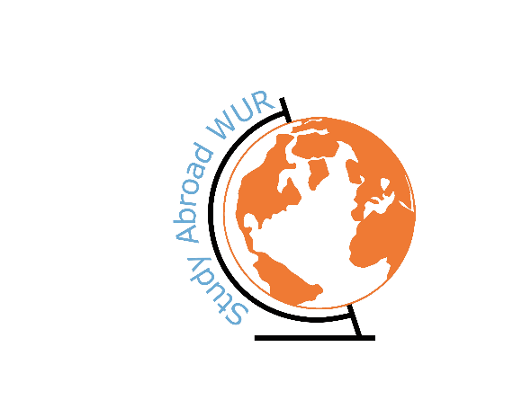

WUR Goes Abroad

# **1. Student Information**

|  |  |
| --- | --- |
|  | |
| Study programme WUR | Bachelor International Development Studies |
| Exchange semester (dd/mm/yyyy) | 13/09/2023 until 10/02/2024 |
| Exchange destination: University | Università degli Studi di Padova |
| Faculty | Human sciences |
| Country | Italy |
| City | Padova |

# **2. Motivation for exchange**

# Why did you choose to go on study exchange?

I wanted to experience living abroad and taking courses on a different university.

**What is the reason you chose for this country/university?**

I mostly chose Italy because I love the country because of its nature, culture and food and I really liked to experience living there. The university I chose because of its courses that interested me.

# **3. Accessibility to reach destination**

## Do you have any tips to reach your exchange destination? I took the flixbus to Italy. It is a long ride, but still doable. It is also really cheap and in Italy we also often took the flixbus to different cities. Another plus is they do not really weight your suitecase to actually be 20 kg ;)

# **4. University and studying**

## Could you provide some general information about the followed courses?

|  |  |  |  |  |  |
| --- | --- | --- | --- | --- | --- |
|  | **Course** | **ECTS** | **Short description of the contents** | **Appreciation of course: 1(low) – 5(high)** | **Remarks** |
| **1** | Terrorism and Security in international history | 9.0 | The course goes into the historical evolution of terrorism of the past 150 years. It gives an insight into how we look at terrorism and how to deal with it. | 5 | I really liked this course as terrorism is a subject that not often is discussed in such a broad way. |
| **2** | Work, Migration and Globalization | 6.0 | This course looks into the relation between work situations, migration processes and globalisation. This is analysed from a historical point of view. | 3 | The course is quite interesting, but a bit familiar for me and not quite elaborate so that was a bit disappointing for me. |
| **3** | History of international Relations | 9.0 | This course dives completely in the development of the history of international relations mostly focussing on the cold war. | 4 | I found this course really interesting as my knowledge on the history of relations is not really wide and this course is really deep and gives so much info on all relations not only focussing on the west. |
| **4** | Contemporary racisms | 6.0 | This course has as main topic racism that is looked at from different fields. A lot of guest lectures are given to give you a view on this. | 3 | I found the main topic of the course quite interesting and some guest lectures were really interesting, but it was a bit chaotic. Also the examination was really easy, so I don’t feel I learned much in this course. |

## 

## What is it like to study there?

The academic level for all courses are really different, some are a lot of work (not necessary difficult) and others are less work. I found studying there really nice as the semester is really long which gives you a lot of time to really get familiar with the topics and also gives you much freedom to enjoy living in Italy. In the end we had a few weeks to study for the exam, this was really nice I think.

## What is the culture of the university?

I found the sphere at the university quite different from Wageningen as there is most of the time much more a distance between the students and the professors. But also I thought the sphere was more relaxed as the period to do the courses in was much longer than we have here in Wageningen.

## What does the university offer students additionally?

The University has a lot of cafeterias and libraries in which you can study. They also have sport accommodation but I did not found that really approachable and the gym is quite expensive. But the city offers also a lot of sport accommodations so you can always join that. Also the Erasmus students have a group chat for every sport you can imagine doing, so you can always meet up with them if you want.

# **5.Housing-travelling-living**

**What are the possibilities for housing?**

*E.g. Availability to sign up for a room on campus, private rooms, rent rates?*

For non-EU citizens they have the possibility to get housing through university. Otherwise there are multiple sites you can visit, facebook, or already entering some groupchats for Erasmus students also might help.

**What is the culture of the country like?**

Well, you probably know from Italy that food is their main thing and yes that is also in Padova definitely the case. But Padova is also the city of the Aperol Spritz, so you can get this everywhere at every time of the day (the Italians say not after 9pm. But you can also get for really cheap in the clubs ;) ). Another nice thing about Padova is there are so many bars, but they are really small so they always stand outside in the streets which gives a really lively sphere to the city.

**Could you give some information about public transport infrastructure?**

In Padova main transportation is actually by bike. There are also busses going through the city and you can easily take the train to Venice or Verona. We often took the flixbus if we wanted to go to a city a bit further away which was really easy to do. And there are also a lot of car rents that cost not that much if you split it, we did this if we wanted to go more in the direction of the Dolomites as this was less easy to reach with public transport. I do have to say that taking the train is not that cheap and you have to take some delay into account.

# **6. Expenses**

**Can you give an indication of your expenses for/during your exchange?**

*E.g. you can also indicate price differences (higher/lower/equal) in comparison to the Netherlands.*

Ticket there: I went by buss what cost me around 60 euros with luggage included

Visa if applicable: x

Vaccinations if applicable:x

Insurances (extra, if applicable): x

Housing costs per month & type of housing/accommodation: I had a shared room for 500 euros a month.

Groceries: I think this was a bit equal with the Netherlands unless you want to eat something different than pasta than it is a bit higher

Public transport: taking the flixbus is a cheap way of transportation, I think the trains are around the same prices or higher (for the faster trains)

Restaurant/going out for dinner: Cheaper, you can often get a pasta between 10 and 15 euros and pizza’s even less, also wine, coffee and spritz are much cheaper.

Daytrips/sight-seeing: I think this is differs. You can make it quite cheap if you want

**Additional remarks regarding expenses?**

# **7. Free time**

**What are must-sees in the area?**

I would definitely recommend seeing the cities of Verona, Venice, Florance and Rome as you now have the possibility to see them in low season or maybe around Christmas which gives a totally different sphere of the city. Also the dolomites is a must.

**What does not appear in a travel guide, but is definitely worth a visit?**

**Do you have general tips and tricks about leisure time?**

There are so many different bars and restaurants in the city there is no right or wrong.

# **8. Challenges & best moment abroad**

**What challenges did you encounter and how did you overcome them?**

I did not experience much challenges as I do not really get homesick. Most difficult was I think getting everything correct with the university as they were not really clear and there were so many documents and things, so that was also a bit exhausting as it just kept going.

**What is your best memory of your time abroad?**

I don’t have a best memory I definitely loved Rome and my hikes in the Dolomites, but just getting an Aperol in the centre is also something I already miss.

# **9. Contact details (optional)**

|  |  |  |
| --- | --- | --- |
| **Is the reader allowed to contact the writer?** | yes ☒ | no ☐ |
| **Name/e-mail** | Kate Commandeur, kate.commandeur@wur.nl | |